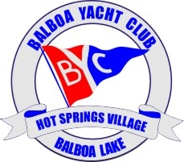
August 7, 2018

Balboa Yacht Club Board of Directors
Meeting Agenda

State Tax Filing Status Report - Jeff

Membership Drive Update – DC
Letter from Leslie Nalley to shore landers

Treasury Report – Jeff

Keep HSV Beautiful – Update – Jim

Events Calendar Update – Stacey
Dock Relay – Summary report
DTH
Holiday Event
Draw Down / Membership Meeting

